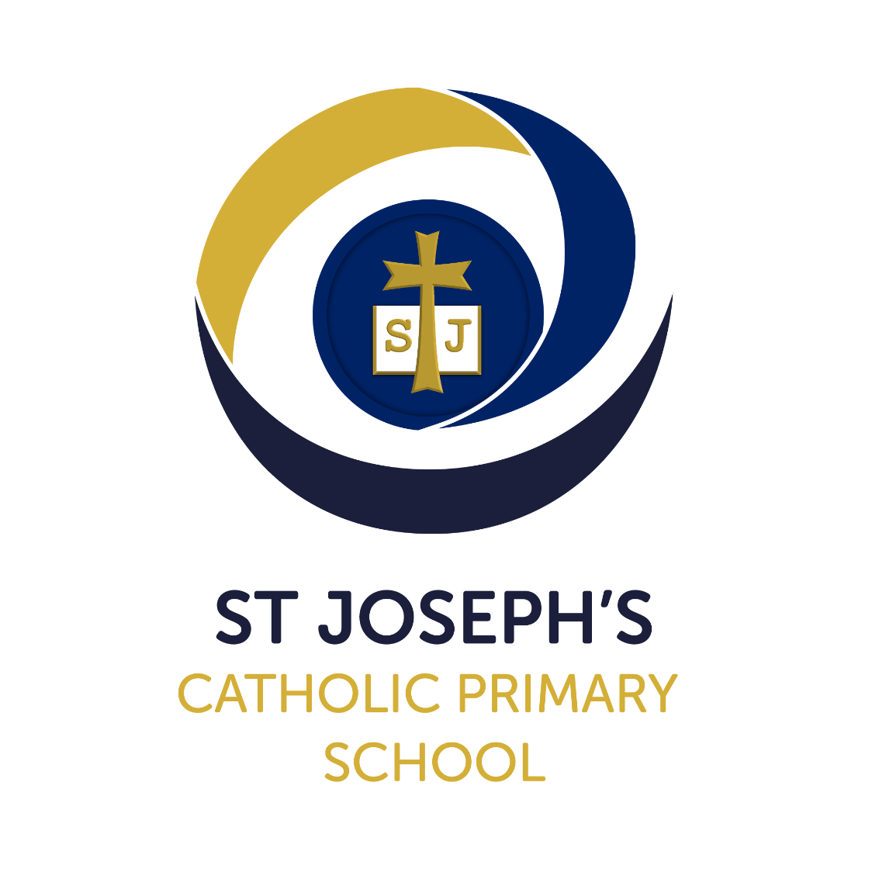

Religious Education Policy

|  |  |
| --- | --- |
| Version: | 1 |
| Date created/updated: | 19th September 2023 |
| Ratified by: | LGB |
| Date ratified: | 9th October 2023 |
| Date issued: | 9th October 2023 |
| Policy Review Date: | October 2025 |
| Post Holder Responsible for Review: | RE Lead |

**Commitment to Equality:**

We are committed to providing a positive working environment which is free from prejudice and unlawful discrimination and any form of harassment, bullying or victimisation. We have developed. a number of key policies to ensure that the principles of Catholic Social Teaching in relation to human dignity and dignity in work become embedded into every aspect of school life and these. policies are reviewed regularly in this regard.

This Religious Education Policy has been approved and adopted by St Josephs’s Catholic Primary School on 9th October 2023 and will be reviewed in October 2025

Signed by the Chair of the Local Governing Body for St Joseph’s Catholic Primary School:

John Coyne

[INSERT ELECTRONIC SIGNATURE]

Signed by the Principal for St Joseph’s Catholic Primary School:

Anthony Wilkes

[INSERT ELECTRONIC SIGNATURE]

School Mission Statement

*In following the Gospel values of Jesus, we are called to love, to learn and to respect one another.*

**Religious Education at St Joseph’s Catholic Primary School**

Religious Education (RE) at St Joseph’s is central to the life of the school, it is a way of life, living and learning through Faith. The beliefs and values studied in RE inspire and draw together every aspect of the life of our school.

We believe that Religious Education is not only about developing each child’s religious knowledge but about providing children with the opportunities and experiences through which their own personal faith can develop.

St Joseph’s School is a place where all children are welcomed and each one nurtured in a union of support between school and parish so each may reach their full potential. As a Catholic school, we seek to enable each child to do their best by following Jesus’ example, who is our Way, Truth and Life.

**The aims of Religious Education at St Ambrose Catholic Primary School:**

* Place Christ at the centre of our community.
* Recognise that everyone is created in the image and likeness of God.
* Foster, deepen and nurture the faith of pupils, staff and parents; the whole school community.
* Promote an understanding and appreciation of Catholic teaching and practice.
* Educate and enrich each individual and develop values that reflect the gospel message and the teaching of the church.
* Foster and promote the moral and spiritual development of pupils.
* Promote and encourage active and committed participation and service in the life of the church and its community.
* Develop a relationship with God by responding to the presence of God in their lives through prayer and reflection.
* Develop knowledge and understanding of the Catholic Faith in partnership with school, home and parish.
* Foster attitudes of respect and understanding for the beliefs and traditions of other faiths and of the global community.
* Develop skills of enquiry such as questioning, discussion, research, applying information, evaluating and making judgements, in order to make sense of the world and to consolidate and express beliefs and values.

**How we meet our stated aims:**   
  
Time Allocation

Each class adheres to at least the minimum time allocation for Religious Education (10%):

|  |  |  |  |
| --- | --- | --- | --- |
| 1 day (8.55 – 3.15) = 380 minutes | |  | 295 mins per day x 5 = 1475 minutes |
| 390 | - 10 mins (am register) | 10% of 1475 = 147 mins (2hrs 27 mins)  2 hours 30 minutes is allocated to RE each week. |
|  | - 15 mins (am break) |  |
|  | - 50 mins (lunch) |  |
|  | - 10 mins (register) |  |
| = 295 minutes per day | |  |

This 10% weekly allocation excludes assemblies, Masses etc.

All pupils, including non-Catholic pupils, follow the Religious Education programme. Local Governing Body representatives are aware of their legal responsibility for the parental right of withdrawal of children from Religious Education and Acts of Worship. However, the religious aspect of school life permeates all areas of school life; therefore, parents who want to exercise this right should consider if this school serves their purpose and discuss their concerns with the Principal.

**Programme of Study**

All Catholic primary schools in the Archdiocese of Birmingham are required to follow the ‘Learning and Growing as the People of God’ Strategy. This programme seeks to provide a wide variety of experience, activities and information appropriate to the central concerns of faith, with its chief emphasis being on the teaching and practices of the Catholic Church.

The programme is child centred, starting from the child's own experience and level of development. Each unit consists of four areas of study. These are:

1. Revelation - God's self-revelation
2. Church - Communion of Life of Christ
3. Celebration - Living the Christian Mystery in worship and prayer
4. Life in Christ - the search for holiness and truth

In each class, the children are taught about the life of Jesus through the scriptures and the beliefs, traditions and practices of the Catholic Church according to their age and level of understanding.

Preparation for Sacraments is a continual process in the R.E. curriculum. In Years 3 and 6 special emphasis is given to Reconciliation, Holy Communion and Confirmation.

**How we plan for Religious Education**

We use the Strategy as our core scheme and this informs short, medium and long term planning. Work is planned with a particular emphasis on the aims of the Unit to be taught and the skills, vocabulary, knowledge and understanding that we want the children to learn.

Teachers plan on a daily/weekly basis, incorporating different skills identifying clearly focussed learning objectives and assessing against these criteria.

The pupils are encouraged to develop a deeper understanding of their faith by asking questions and reflecting on their experience.

The pupils are encouraged to develop their ability to make a personal response to life experiences and formulate questions as part of their response.

**How we teach Religious Education**

All of us as teachers recognise our special responsibility to pass on the Catholic Faith and nurture the individual faith journeys of the pupils in our care.

We regard this as fundamental to our teaching and believe it permeates every aspect of our school life. In our organisation and delivery of the whole curriculum we aim to develop the pupils' understanding of the world in which we live by encouraging intellectual curiosity. Pupils are encouraged to seek answers to some of "life's great questions" and we believe that it is our job as teachers, to guide the pupils where appropriate through open ended enquiry. All of the teaching and learning should be concerned with preparing the pupils for life and the ability to make informed decisions without prejudice.

The organisation of out teaching can be whole class or in groups, according to the task. Children may work in pairs or small groups for some activities. Differentiation is provided for according to individual need, by teacher intervention, also by task, by questioning and responses and by expectations.

**The Global Dimension**

Catholicism by its definition is a universal Church. This means that within its practices, celebrations, commemorations there are huge amounts of diversity. This diversity is something to be celebrated. Children need to learn how Catholics in other parts of the world celebrate and commemorate key events in the life of the Church. They also need to learn about the people and saints who hold a special importance and significance to Catholic people in specific parts of the world.

**Teaching about other Faiths and Religions**

*It is required by the Bishops, who state that the Catholic nature of our schools entails “a willingness… to try to understand better the religion of one’s neighbours, and to experience something of their*

*religious life and culture.” Catholic Bishop’s Conference P.3*

The purpose of children learning about people of other faiths and religions is to ensure that children grow in awareness and appreciation not only of their own cultural heritage but the cultural heritage of other people regardless of whether they live within the same local community, elsewhere in the UK or part of the global community beyond. Promoting and developing this aspect of education helps us to work towards the ultimate goal of creating a harmonious and tolerant society where discrimination of any form is not accepted.

Other Faiths and Religions are taught across the key stages. Reception learn about Judaism. Year One learn about Islam. Year Two learn about Hinduism. Year Three learn about Islam. Year Four learn about Buddhism. Year 5 learn about Sikhism. Year 6 learn about Judaism. They also develop their knowledge and understanding how Catholics in other parts of the world celebrate and commemorate key events in the life of the Church.

The children are encouraged to develop respect for differences and an appreciation of the diversity of religious beliefs in order to prepare them for life in our ever-changing multicultural society.

Individual lessons may include: speaking and listening, drama, research and investigation, evaluation and personal response. Homework activities are also linked to this area.

**Equal Opportunities**

At St Joseph’s, all children have equal access to the Religious Education curriculum. We believe that all children, irrespective of their faith background have valuable roles in our school family. The experiences of all of our children including those of different faiths and cultural backgrounds, enrich and help to develop the faith journeys of the members of our school family.

**Inclusion**

All teachers differentiate for all learners. Each individual child is supported according to their needs and levels of development. Teachers provide suitable learning activities to cater for the range of abilities within each class. We strive to support all children to enable them to achieve at school. In order to do this many steps are taken in order to support them through in their journey of learning. Each small step is tracked and monitored so that small steps of progress can celebrated.

**Catholic Social Teaching**

At St Joseph’s we teach children about the principles of Catholic Social Teaching (CST). As Catholics, we believe that it is our role to help others in need and care for the world we have been given. The 7 principles of Catholic social teachings are included in all areas of the curriculum:

* Dignity of the Human Person
* Stewardship of God’s Creation
* Solidarity and the Common Good
* Family and Community
* Dignity of Work and the Right of Workers
* Rights and Responsibilities
* Options for the poor and vulnerable

**British Values and School Virtues**

The school promotes the fundamental British values of democracy, mutual respect and tolerance of those with different faiths and the rule of law through the school Virtues. As Catholics we believe in the importance of developing a virtuous life. The Catechism describes a virtue as “an interior disposition, a positive habit, a passion that has been placed at the service of the good.”

Each half term the focus will change and schools across the Archdiocese will focus upon the same set of virtues at the same time. The Profile also provides a thematic focus for Liturgy and Prayer (Collective Worship) and SMSVC over a specified length of time. Whilst all of the aspects of the profile are being touched upon the school can really emphasise a particular pair of words throughout a half term.

All pupils are educated in a culture of inclusion, tolerance and mutual respect, providing pupils with a net of values that enable them to play a full part in British society in service of the common good.

**Our School Virtues**:

|  |  |
| --- | --- |
| Pupils in a school in the Archdiocese of Birmingham are growing to be … | Schools in the Archdiocese of Birmingham help their  pupils grow… |
| **Grateful** for their own gifts, for the gift of other people, and for the blessings of each day; and **generous** with their gifts, now and in the future. | By encouraging them to know and be **grateful** for all their gifts, developing them to the full so that they can be **generous** in the service of others. |
| **Attentive** to their experience and to their vocation; and **discerning** about the choices they make and the effects of those choices. | By promoting the practice of **attentive** reflection and **discerning** decision making: in teaching, in the examen, prayer and retreats; and through the practice and example of school leaders and staff. |
| **Compassionate** towards others, near and far, especially the less fortunate; and **loving** by their just actions and forgiving words. | By being **compassionate** and **loving** in the way pupils are treated, especially when a pupil is in trouble; and by opening pupils’ eyes to those who suffer poverty, injustice or violence. |
| **Faith-filled** in their beliefs and **hopeful** for the future. | By passing on the living and **faith-filled** tradition of Jesus Christ; by having persevering faith in the pupils, and by encouraging them in turn, to have faith and **hope** in themselves and others. |
| **Eloquent** and **truthful** in what they say of themselves, the relations between people, and the world. | By developing an **eloquent** language which pupils can use to understand and articulate their emotions, beliefs, and questions, encouraged by the example of their teachers to be **truthful** in the way they represent themselves and speak about the world. |
| **Learned**, finding God in all things; and **wise** in the ways they use their learning for the common good. | By the breadth and depth of the curriculum; by excellence of teaching, and the creation of opportunities to become more **learned** and **wise**. |
| **Curious** about everything; and **active** in their engagement with the world, changing what they can for the better. | By leading pupils to be **curious** about the universe and all human activity, and to take increasing responsibility for their own learning, and by providing opportunities for them to be **active** in the life of the school, the Church, and the wider community. |
| **Intentional** in the way they live and use the resources of the earth, guided by conscience; and **prophetic** in the example they set to others. | By being a school community which is **intentional** in its way of proceeding to build-up quality of life; and which is **prophetic** in the way it offers an alternative vision of education and the human person rooted in the gospel. |

Each week, the class teacher selects one pupil from each class who they feel have demonstrated the two focus virtues. Gifts from God Assemblies take place on Fridays – pupils are awarded certificates from the Head and Deputy Head boys and girls. The names of these children are shared on the newsletter and the pupils have tea with Mr Wilkes the following week.

**SMSVC**

* The Religious Education curriculum underpins the moral development of pupils throughout their faith journey
* Resources used and topics covered are founded on Catholic moral principles. Guidance may be sought from the Diocese and from the Parish Priest, as necessary.
* Pupils are encouraged to become mature and responsible Christians at all times and are valued, respected and rewarded for their work, actions or attitude within the classroom and at our weekly celebration assemblies.
* Pupil voice is of great importance – we have a school council who meet regularly and have re-launched (post-covid) a Mini Vinnies programme in school.
* Social development is an on-going programme, incorporated into all curriculum areas, everyday experiences and teaching, showing pupils how to interact, accept and understand others.
* Pupils are encouraged to be aware of people less fortunate than themselves by supporting and organising fund-raising. These include CAFOD, Operation Christmas Child, Father Hudson’s Home, Water Aid, Help for Heroes. They are also encouraged to respond to current national disasters as part of their Catholic Mission and Catholic Social Teaching.

**Prayer**   
  
Pupils have the opportunity to experience different forms of prayer – formal, traditional prayers of the church and school day, spontaneous, meditative and reflective. Through prayer, we aim to develop a personal relationship with God. This will not just happen however, and we need to create the right atmosphere. Prayer time should be quality time and children should be taught in a meaningful way in order to develop a real ‘sense of prayer’. This may take place in whole school, key stage or class settings.

Classes are taught about prayer in accordance with Diocesan guidelines and the children therefore need to learn traditional prayer formulae. Pupils should be encouraged to understand why we say the prayer and what the prayer is about at different times of the year, especially where special forms of prayer are used e.g. Stations of the Cross in Lent, the Rosary in May and October.

All classes have a focal point for prayer and religious artefacts with an altar in each classroom to support pupils in their prayer and worship. Other areas of the school are used for prayer including the school prayer area on the KS2 corridor, the memorial garden and the school hall.

**Prayer and Liturgy (Collective Worship)**  
  
**As well as the pupil's core entitlement, our pupils are provided with valuable experiences in prayer and liturgy, some of which are built into our teaching.**

We provide for our pupils frequent and varied opportunities for collective worship in our Masses, assemblies and prayer services which are of fundamental importance to the life of the school. (see Prayer and Liturgy Policy). The children take an active part in the preparation and celebration of Masses, services of Reconciliation and assemblies. This encourages their active involvement in the sacramental life of the church as well as fostering a habit of prayer, in both formal and informal settings; as a whole school or in smaller groups e.g. junior or infant classes, individual classes.

**Sacramental Preparation**   
  
Pupils in Year 3 are prepared for the Sacrament of Reconciliation, Year 4 prepare for Holy Communion while pupils in Year 6 begin preparations for the Sacrament of Confirmation in the Autumn term of Year 6. This is a collaborative approach between St Joseph’s school, parish clergy and families, enabling the children to appreciate and develop their understanding of the importance of their place in the community. The RE Coordinator and Class Teacher(s) work closely with the Parish Priest and Catechists to ensure the successful running of the Sacramental preparation programmes. Workshops for parents and children take place during the year as part of the preparation programme.

**Other Opportunities**

* Music, Art, Drama, History and Literature play an important role in the teaching of Religious Education and are used to enhance the pupils’ learning experiences.
* At significant times in the year, educational visits / retreats are organised to support the spiritual and cultural development of pupils, e.g. St Chad’s Cathedral, Harvington Hall, Alton Castle.
* Vocational experts and other speakers visit the school to promote Vocations throughout the year across the school.

**Information Technology and Religious Education**

At St Joseph’s, we use Information Technology to support all areas of the curriculum. Religious Education is no exception and children are able to use a variety of resources which include a range of interactive stories from the Bible, DVD’s, virtual tours of other places of worship, digital photography, YouTube videos, Purple Mash platform. Teachers are also encouraged to utilise a wide range of websites to support their teaching and use other technical equipment such as iPads to enhance the Religious Education curriculum.

**Resources**

Resourcing is given a high priority at our school in line with core subjects and it has always been our practice to ensure that we have resources of a high quality to support the delivery of Religious Education.

* + Resources to support the units in "Learning and Growing as the People of God, have been purchased to supplement other resources.
  + Bibles - a variety of Bibles and Bible reference books in the Iibrary and classrooms.
  + Assembly and teachers, external visitors, books for prayer and worship
  + A variety of story books, prayer books, collections of Mass themes and ideas for Acts of Worship
  + Catholic artefacts of faith as well as artefacts for other faiths.
  + Crucifixes of various kinds, icons, baptismal candles, a paschal candle and sets of Rosary beads
  + lnformation books including those of other faiths
  + Posters and pictures
  + Prayer books and bible story books or religion/moral based stories in each classroom and in the main library.
  + Meditative music used in prayer and liturgy
  + CDs and DVDs
  + Multicultural Resources and Artefacts

## **Assessing, Recording and Reporting**

In assessing children's work, we recognise that faith cannot be assessed. We do, however, assess how well the children understand and remember what is taught, against our Learning Objectives, which are derived from the Archdiocese Strategy as well as the Religious Education Curriculum Directory and are built into our planning.

These assessments are recorded on our whole school excel sheet and age related strands sheet.

Reporting takes place through parent consultation meetings, annual written reports and at other meetings requested by parents or the school.

**Management and Organisation**

The RE Coordinator has responsibility for the development of RE throughout the school. Responsibilities include:

* Formulating objectives for the RE Development Plan and Self Evaluation Form (with support from the Principal).
* Policy writing, implementing and monitoring
* Planning – ensuring that long term plans are reviewed in line with the School Development Plan.
* Evaluating and monitoring of teaching and learning in RE.
* Providing support for all staff as required and supporting induction of new staff.
* Reporting developments to the Principal and the Local Governing Body
* Identifying training needs and inform staff of new developments.
* Providing in-service training.
* Auditing resources and purchasing resources following consultation with staff.

Class teachers are responsible for:

* planning and providing learning opportunities using the diocesan schemes.
* using agreed long and short-term planning formats.
* providing assessment data in line with Diocesan expectations.
* providing ongoing assessment data to support attainment target judgements.

The Principal and RE Coordinator are responsible for the implementation, monitoring and evaluation of the RE policy, RE Development Plan, expectations in relation to learning and teaching, and identifying training needs throughout the school. The RE Local Governing Body Representative liaises with the RE Coordinator. The Coordinator reports to the Local Governing Body Committee through the Principal’s Report

**Monitoring and Evaluation**  
  
Monitoring takes place in line with the school’s monitoring policy. The policy document and curriculum planning are evaluated, and revised if necessary, in line with school development. The RE Coordinator monitors and evaluates the policy and teaching and learning and reports to the link Local Governing Body Representative.

**Keeping Children safe in Education 2023.**

In RE at St Joseph’s, in line with Keeping Children Safe in Education 2023, we take a child centred and coordinated approach to safeguarding.

Safeguarding and promoting the welfare of children is everyone’s responsibility. Everyone who comes into contact with children and their families has a role to play. In order to fulfil this responsibility effectively, all practitioners make sure their approach is child centred. This means that they consider at all times, what is in the best interests of the child.

Safeguarding and promoting the welfare of children is defined as:

* protecting children from maltreatment
* preventing the impairment of children’s mental and physical health or development
* ensuring that children grow up in circumstances consistent with the provision of safe and effective care, and
* taking action to enable all children to have the best outcomes.

**KCSIE 2023**

**RE Coordinator:** Mrs Jo McCole  
Principal: Mr Anthony Wilkes  
RE Link Local Governing Body Representative: Fr Philip Griffin  
Chair of the Local Governing Body Committee: Mr John Coyne